3D shear-layer driven cavity flow at $Re_{L_c}= 7826$
Author : Y. Fraigneau, LISN, UMR CNRS 9015 (yann.fraigneau@lisn.fr)
Date : July 2020
Simulation type : DNS (code Sunfluidh – Sunfluidh code)
Location : DATABASE_CAVITY3D_R2_RE7826_PER1.0_DNS/NOFORCINGTERM
Status : Free access for laboratory members, on request for external members
Data size : ~ 31 Gb
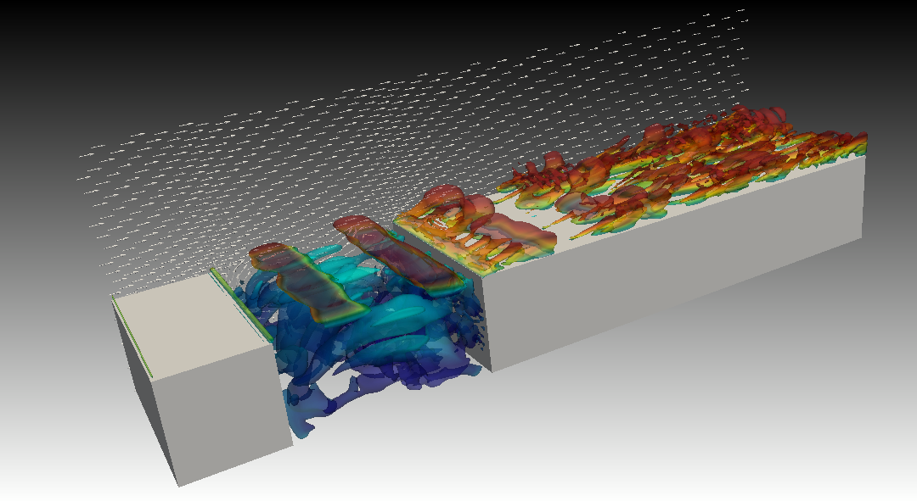
A video is available here
Come back to first page

Simulation settings

2D sketch
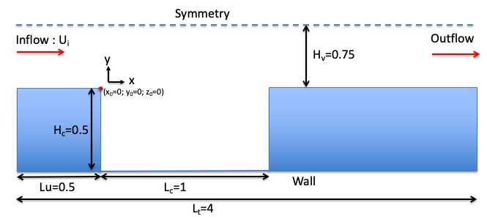

Referential : cartesian geometry
- axes :
  - x(i) : downstream direction
  - y(j) : normal direction
  - z(k) : spanwise direction
- origin :
  - : upstream edge of the cavity
  - : upstream edge of the cavity
  - : upstream edge of the cavity, at the mid-span location

Reference scales
- Density : mass density of the fluid ()
- Length : cavity length ()
- Velocity : inlet bulk velocity ()
- Dynamic viscosity : dynamic viscosity of the fluid ()
- Reynolds number :

Non-dimensionalised data
- velocity :
- density :
- coordinates : , ,

Computational domain
- Domain scope
  - Downstream direction(x) :
  - Normal direction (y) :
  - Spanwise direction (z) :
  - upstream vein length :
  - cavity height :
- Boundary conditions
  - Inlet : Blasius' profile at . Boundary layer thickness
  - Outlet : Orlansky's type at
  - Wall conditions : floor and cavity walls
  - Periodicity : lateral ends of the domain (spanwise direction)
  - Symmetry plan : top of the domain
- Spatial resolution :
  - Grid : per subdomain (1.572.864 cells over the domain)
  - About cell-size
    - (downstream direction)
    - (normal direction)
    - (spanwise direction)
Come back to first page

Data features

- Time series from probes
  - Physical quantities : velocity components along x, y and z directions (u,v,w) and pressure (p)
  - 11 probes
  - Time step= 0.0525 time unit
  - Time range : 200 to 400 time units
  - Locations (In vertical mid-plan at )
    - Xi=0.2 , Xj= -0.3 , Xk= 0.0
    - Xi=0.5 , Xj= -0.3 , Xk= 0.0
    - Xi=0.8 , Xj= -0.3 , Xk= 0.0
    - Xi=0.1 , Xj= 0.05 , Xk= 0.0
    - Xi=0.5 , Xj= 0.05 , Xk= 0.0
    - Xi=0.9 , Xj= 0.05 , Xk= 0.0
    - Xi=1.0 , Xj= 0.05 , Xk= 0.0
  - File name (per physical quantity) : x_ins_yyyyy.d with x= u,v,w,p and 'yyyyy' the MPI subdomain ID
- 3D snapshots
  - Instantaneous fields : velocity components in x, y and z directions (U,V,W) and pressure (P)
  - Recording rate : 0.25 time unit
  - Time range from from 210.0 to 400.0 time units
  - File name : res_xxxxx_yyyyyyy.d (xxxxx : MPI subdomain ID, yyyyyyy : Time ID)
    - MPI subdomain ID: 0
    - Time ID : from 1 to 760
- 2D slices
  - Instantaneous fields : velocity components in x, y and z directions (U,V,W) and pressure (P)
  - Recording rate : 0.05 time units
  - Time range from from 210 to 400 time units
  - File name : slice_n_idir_xxxxx_yyyyyyy.d (n : slice number ID, idir : normal orientation= 1: x(i), 2: y(j), 3: z(k), xxxxx : MPI subdomain ID, yyyyyyy : Time ID)
    - MPI subdomain ID: 0
    - Time ID : from 1 to 3801
  - 8 slices
    - slice ID : 1 - normal orientation : spanwise - location :
    - slice ID : 2 - normal orientation : spanwise - location :
    - slice ID : 3 - normal orientation : spanwise - location :
    - slice ID : 4 - normal orientation : spanwise - location :
    - slice ID : 5 - normal orientation : spanwise - location :
    - slice ID : 6 - normal orientation : spanwise - location :
    - slice ID : 7 - normal orientation : normal - location :
    - slice ID : 8 - normal orientation : normal - location :
- Statistics
  - fields : (i,j : indexes of direction x, y or z)
    - Mean fields of velocity components (<Ui>) and pressure (<P>)
    - Mean fields of quadratic quantities (<P2>, <UiUj>)
  - Time average computation
  - Time startup = 200.0 time units
  - Time range per file = 50.0 time units
  - Total time range from 200.0 to 400.0 time units
  - file name : rst_xxxxx_yyyyyyy.d (xxxxx : MPI subdomain ID, yyyyyyy : Time ID)
    - MPI subdomain ID : 0
    - Time ID : 1 to 4
Come back to first page

Database organisation

Data size : ~ 9.5 Gb
Main directory : /vol/DATABASE_MECA/DATABASE_CAVITY3D_R2_RE7826_PER1.0_DNS/NOFORCINGTERM
For more details about files, see the wiki doc of Sunfluidh

Directories & files
/GRID : contains all ASCII files about grid setup
input data file : data_meshgen.d
report on grid features : report_meshgen.d
grid files for sunfluidh: maillx.d, mailly.d, maillz.d
check files (ASCII) : check_mesh_I.d,check_mesh_J.d,check_mesh_K.d
(3 columns : indices, cell-face coordinates, cell size)
/DATASETUP : ASCII files
input data file for sunfluidh : input3d.dat
velocity profile (Blasius' boundary layer) at the inlet : inlet_velocity_profile.dat
/TIMESERIES : contains time series recorded over the time range [200,513.3]
ASCII files : x_ins_00000.d with x= u,v,w,p
/SNAPSHOTS : snapshots binary files res_xxxxx_yyyyyyy.d
/STATISTICS : statistics binary files files rst_xxxxx_yyyyyyy.d
/RESTART_AR : backup/restart archive save_t400.tar for time= 400 time units
Come back to first page

