3D turbulent channel flow at $Re_{\tau}= 180$
Author : Y. Fraigneau CNRS-LIMSI (yann.fraigneau@lisn.fr)
Date : June 2020
Simulation type : DNS (Sunfluidh code) Location : DATABASE_CHANNELFLOW_RETAU180_DNS
Status : Free access
Data size : ~ 13 Gb
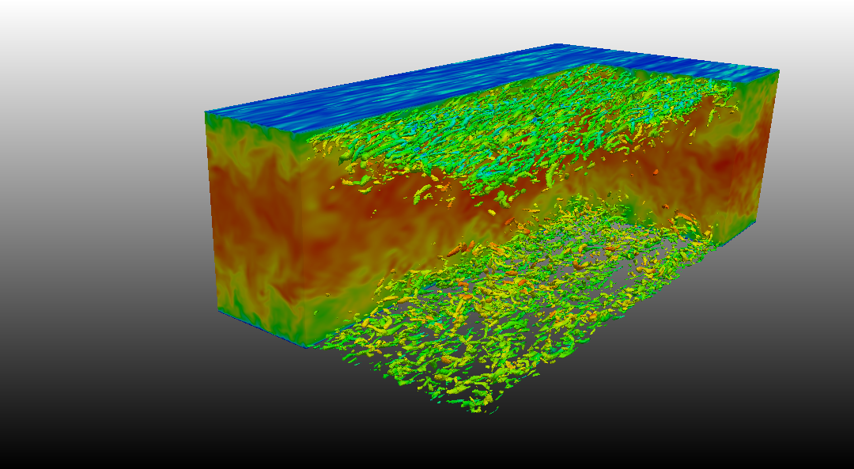

Come back to first page

Simulation settings

2D sketch
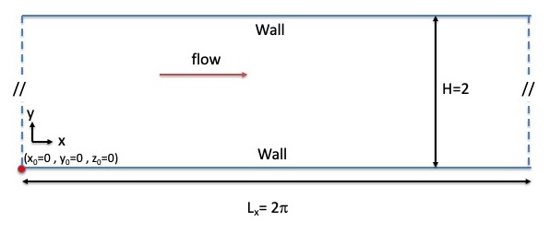

Referential : cartesian geometry
- axes :
  - x(i) : downstream direction
  - y(j) : normal direction
  - z(k) : spanwise direction
- origin :
  - : left down corner
  - : left down corner
  - : left down corner

Reference scales
- Density : mass density of the fluid ()
- Length : half height of the channel ()
- Velocity : wall friction velocity ()
- Dynamic viscosity : dynamic viscosity of the fluid ()
- Reynolds number :

Non-dimensionalised data
- velocity :
- density :
- coordinates : , ,

Computational domain
- Domain scope
  - Downstream direction(x) :
  - Normal direction (y) :
  - Spanwise direction (z) :
- Boundary conditions
  - Wall conditions : Top and low walls of the domain
  - Periodicity : lateral ends of the domain in and directions
- Spatial resolution :
  - Grid : (1.179.648 cells over the domain)
  - About cell-size
    - (downstream direction)
    - (normal direction)
    - (normal direction)

Data features

- Time series from probes
  - Physical quantities : velocity components along x, y and z directions (u,v,w) and pressure (p)
  - 7 probes
  - Time step= 0.0126 time unit
  - Time range : 97.09 to 301.09 time units
  - Locations (In vertical plan at )
    - Xi= 3.14, Xj= 0.25 , Xk= 1.57
    - Xi= 3.14, Xj= 0.75 , Xk= 1.57
    - Xi= 3.14, Xj= 1.00 , Xk= 1.57
    - Xi= 3.14, Xj= 1.25 , Xk= 1.57
    - Xi= 3.14, Xj= 1.50 , Xk= 1.57
    - Xi= 3.14, Xj= 1.75 , Xk= 1.57
- File name (per physical quantity): x_ins_00000.d with x= u,v,w,p
- 3D snapshots
  - Instantaneous fields : velocity components in x, y and z directions (U,V,W) and pressure (P)
  - Recording rate : 0.3 time units
  - Time range from 97.39 to 301.09 time units
  - File name : res_xxxxx_yyyyyyy.d (xxxxx : MPI subdomain ID, yyyyyyy : Time ID)
    - MPI subdomain ID: 0
    - Time ID : from 11 to 690
- Statistics
  - fields : (i,j : indexes of direction x, y or z)
    - Mean fields of velocity components (<Ui>) and pressure (<P>)
    - Mean fields of quadratic quantities (<P2>, <UiUj>)
  - Time average computation
  - Time startup = 100.0 time units
  - Time range per file = 25.0 time units
  - Total time range from 100.0 to 300 time units
  - file name : rst_xxxxx_yyyyyyy.d (xxxxx : MPI subdomain ID, yyyyyyy : Time ID)
    - MPI subdomain ID : 0
    - Time ID : from 1 to 35

Database organisation

Data size : ~ 13 Gb
Main directory : /vol/DATABASE_MECA/DATABASE_CHANNELFLOW_RETAU180_DNS
For more details about files, see the the wiki doc of Sunfluidh

Directories & files
/GRID : contains all ASCII files about grid setup
input data file : data_meshgen.d
report on grid features : report_meshgen.d
grid files for sunfluidh: maillx.d, mailly.d, maillz.d
check files (ASCII) : check_mesh_I.d,check_mesh_J.d,check_mesh_K.d
(3 columns : indices, cell-face coordinates, cell size)
/DATASETUP : ASCII files
input data file for sunfluidh : input3d.dat
/TIMESERIES : contains time series recorded over the time range [16.64 ; 199.44]
ASCII files : x_ins_yyyyy.d with x= u,v,w,p
time series files are sliced in storage directories CAS-MPI200-n (n from 5 to 50)
/SNAPSHOTS : snapshots binary files res_xxxxx_yyyyyyy.d
files stored in archive files : res_yyyyyyy.tar for each time ID
/STATISTICS : statistics binary files files rst_xxxxx_yyyyyyy.d
files stored in archive files : res_z.tar , z is an ID number (from 1 to 35)
/RESTART_AR : backup/restart archive save.tar at time 301.09
/FROM_COMPUTATION : regroups some files related to the simulation : checkcalc_00000.dat and checkdata_00000.dat
Come back to first page

