DATABASE-FLMECA (in progress)
Author : Yann Fraigneau
- Here you will find detailed information on the databases relating to several numerical fluid mechanics studies carried out at LISN (ex LIMSI).
- Numerical simulations are DNS or LES which were carried out using the code Sunfluidh.
- The use of databases is currently reserved to the members of LISN but conditional access rights can be considered for any collaborator.
- For security reason, the database is not in open access. For anyone interested in accessing data sets, please contact Yann Fraigneau by e-mail (yann.fraigneau-toremove@lisn.fr-toremove)
 | Information about the code Sunfluidh, files provided by the code and tools for reading these files can be found in the wiki sunfluidh.

DATABASE ORGANIZATION (for internal use)

The full database is stored on the server “DATAMECA”. Each dataset is generally organized as follows :
The path to access the root directory of the database (DATABASE_“name”) can be defined in two ways:
- /vol/DATABASE_MECA/DATABASE_“name” for databases in free access
- /vol/DATABASE_MECA/RESTRICTED_ACCESS/DATABASE_“name” for databases in restricted access
In the root directory are present folders in which are sorted the different kinds of data files :
- /GRID : grid files used by the CFD code to perform the simulation as well as data files used to create the grid (with 'meshgen') and report files containing some information about the grid features.
- /DATASETUP : input data files used by the CFD code (except the grid files) to compute the simulation.
- /SNAPSHOTS : instantaneous fields of physical quantities (also called snapshots)
- /STATISTICS : space and time averaged data
- /TIMESERIES : time series provided from probes placed in the flow. Sometimes are present time series about residual quantities or other data which are described according to the studied case.
- /SLICES : 2D instantaneous fields recorded over specific plans (slices in 3D computational domain).
- /RESTART_AR : any useful files in order to resume the simulation from a specific time.
- /FROM_COMPUTATION : Some potentially useful files resulting from the simulation used to check the computation behaviour during the run.
Some data are sometimes unavailable (this depends on the aim of the numerical study).

CONTENTS

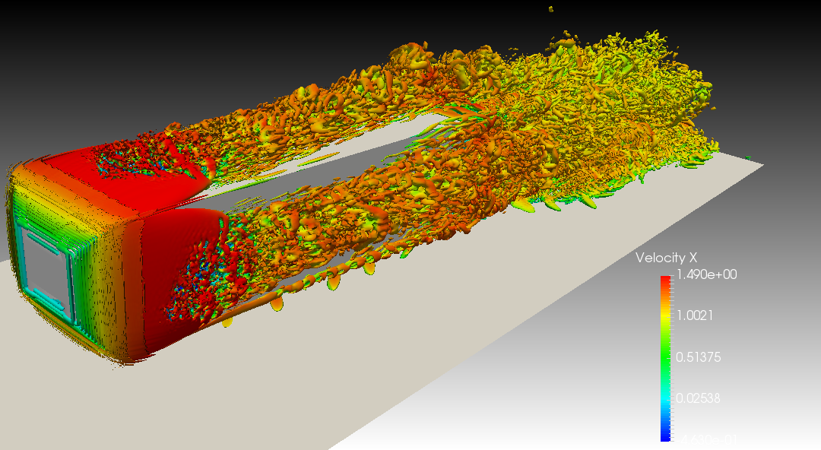
- 3D Ahmed body flow - $Re_H=10000$
A direct numerical simulation using cells over a time range of time units.
The data size is about Gb.
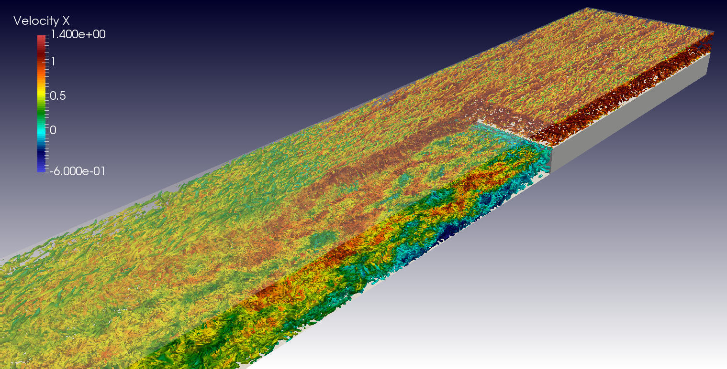
- 3D backward-facing step flow - $Re_h= 6000$
A direct numerical simulation using cells split into subdomains (with cells per subdomain) over a time range of time units.
The data size is about Tb.
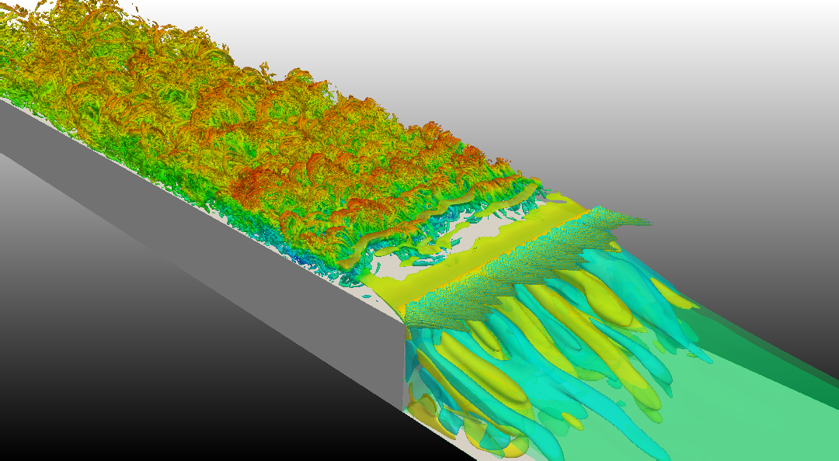
- 3D forward-facing step flow - $Re_h= 8000$ (laminar inflow)
A direct numerical simulation using cells split into subdomains (with cells per subdomain) over a time range of time units.
The data size is about Tb.
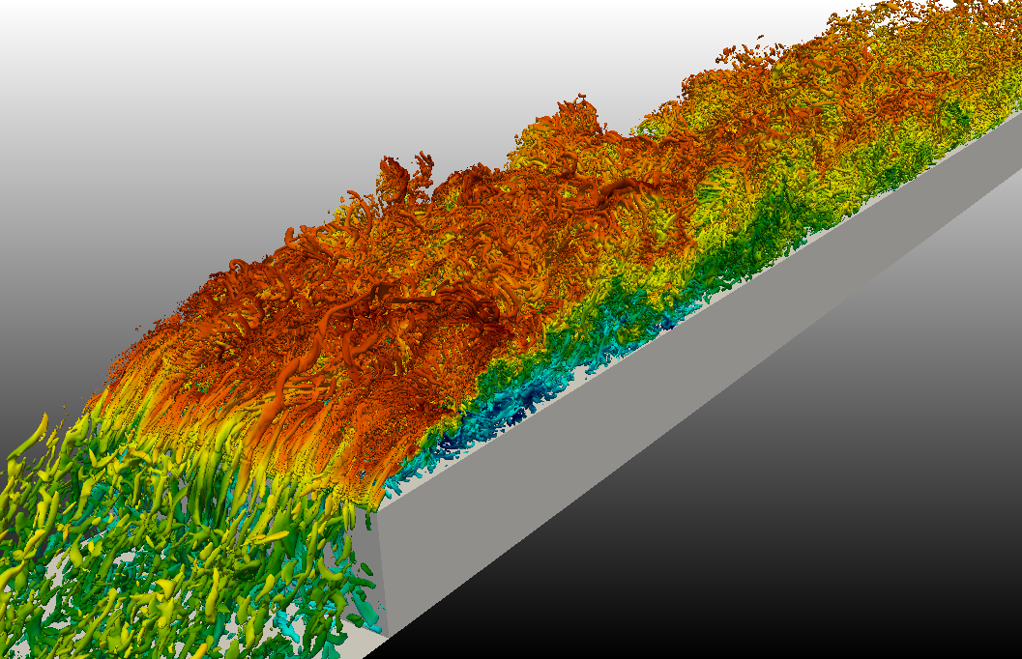
- 3D forward-facing step flow - $Re_h= 8000$ (turbulent inflow)
A direct numerical simulation using cells split into subdomains (with cells per subdomain) over a time range of time units.
The data size is about Tb.
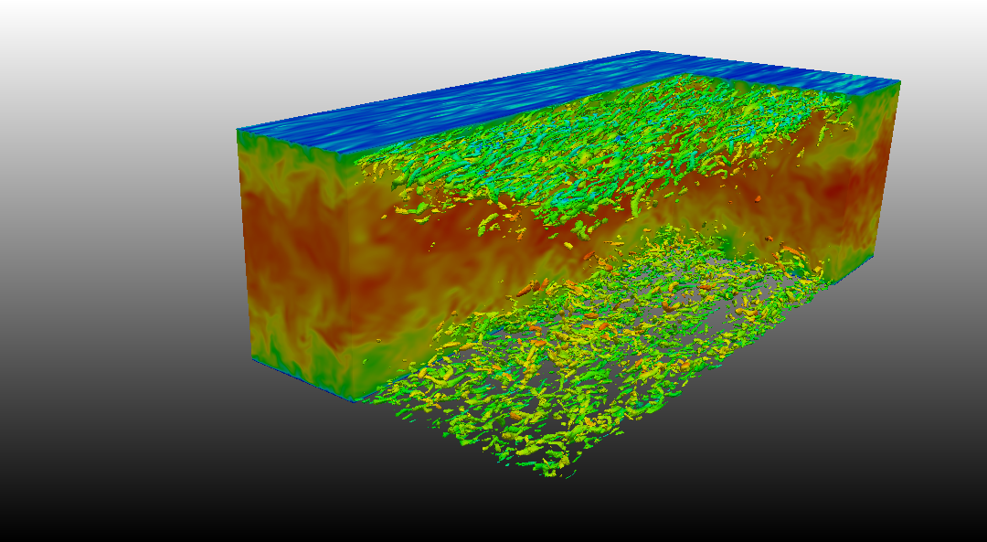
- 3D turbulent channel flow - $Re_{\tau}=590$
A large eddy simulation using cells split into subdomains over a time range of time units.
The data size is about Tb.
- 3D turbulent channel flow - $Re_{\tau}=180$
A direct numerical simulation using cells over a time range of time units.
The data size is about Gb.
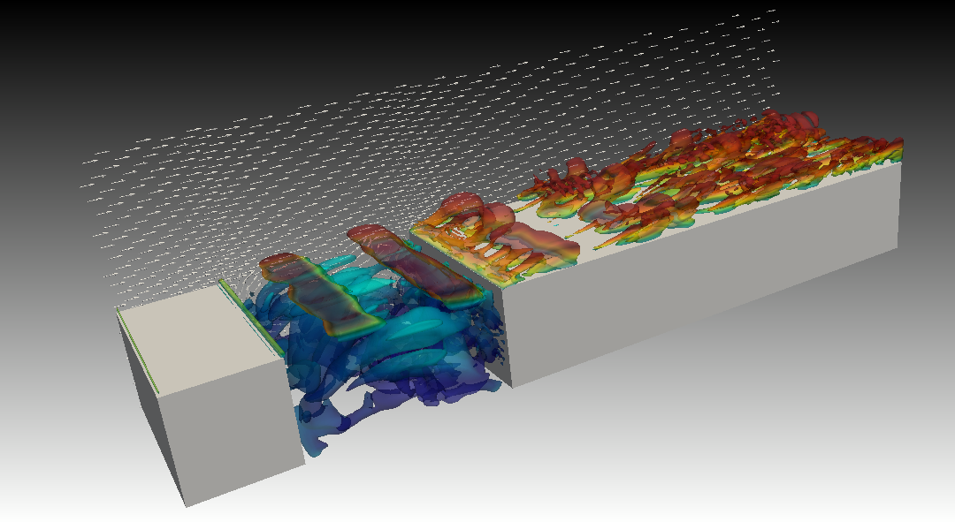
- 3D shear-layer driven cavity flow - $Re_{L_c}= 7826$
A direct numerical simulation using cells over a time range of time units.
The data size is about Gb.
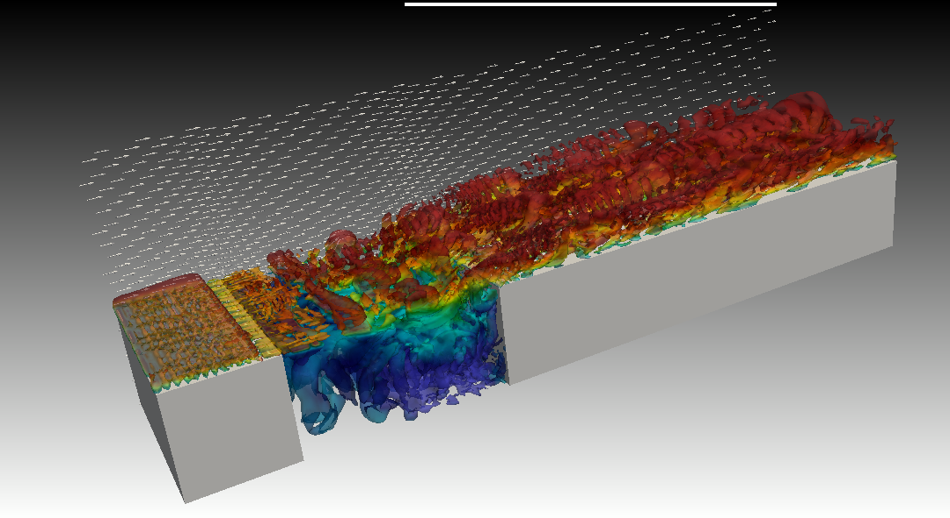
- 3D shear-layer driven cavity flow with a constant forcing source term - $Re_{L_c}= 7826$
A direct numerical simulation using cells over a time range of time units.
The data size is about Gb.
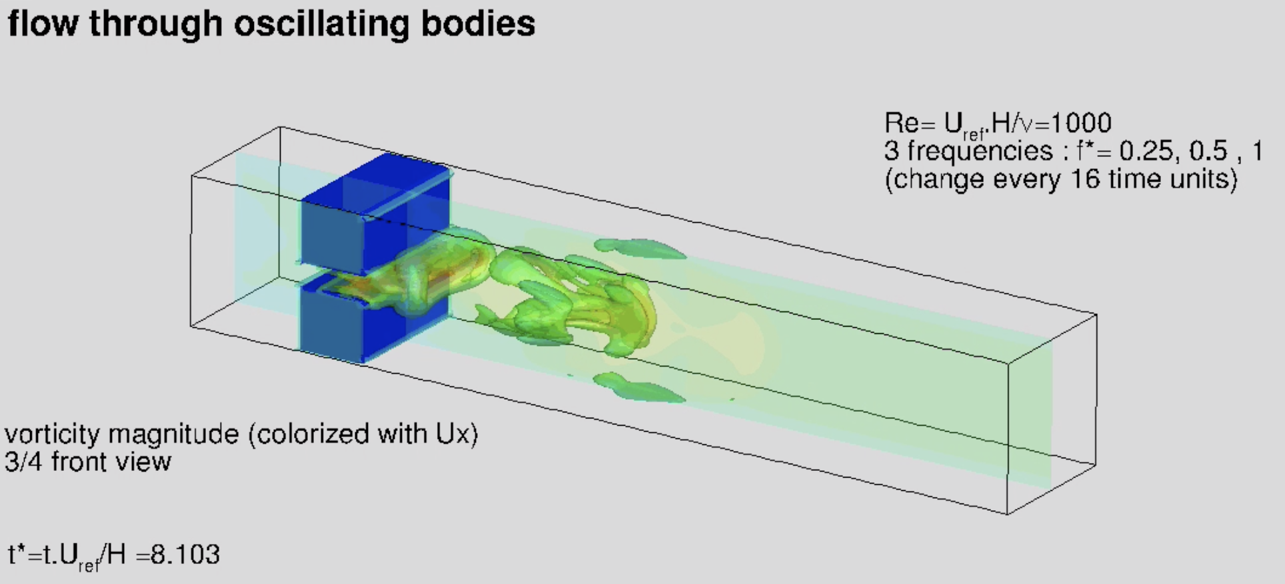
- 3D planar jet through oscillating bodies - $Re_{L_y}=1000$
A direct numerical simulation using cells over a time range of time units on which three oscillation frequencies are considered.
The data size is about Gb.
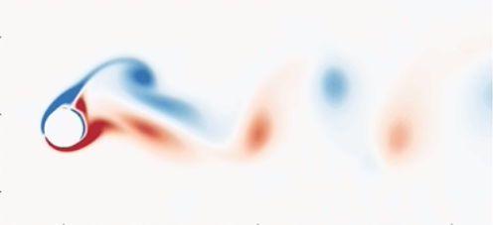
- 2D flow around an oscillating cylinder - $Re_D=185$
Direct numerical simulations using cells over a time range of time units. Four different configurations have been considered ( oscillation magnitudes and frequencies).
The data size is about Gb.
- 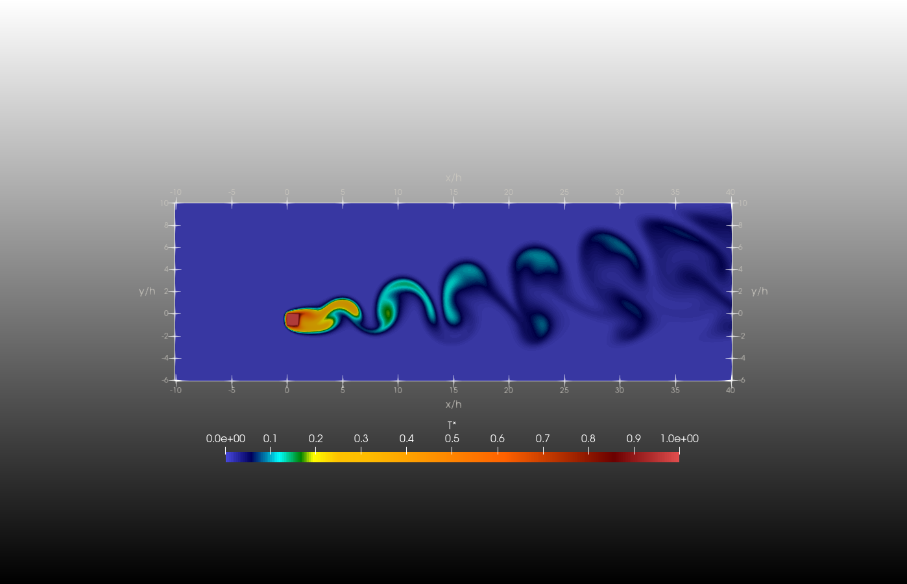 2D flow around a heated square-cylinder - $Re_h=50$, $Ra=5.10^6$
Direct numerical simulation using cells over a time range of time units
The data size is about Gb.
Videos about some of these simulations can be seen here

