3D AHMED-BODY FLOW at $Re_H= 10000$
Author : Y. Fraigneau CNRS-LIMSI (yann.fraigneau@lisn.fr)
Date : July 2018
Simulation type : DNS (Sunfluidh code)
Location : DATABASE_AHMEDBODY_RE10000_DNS
Status : Restricted access
Data size : ~ 609 Gb
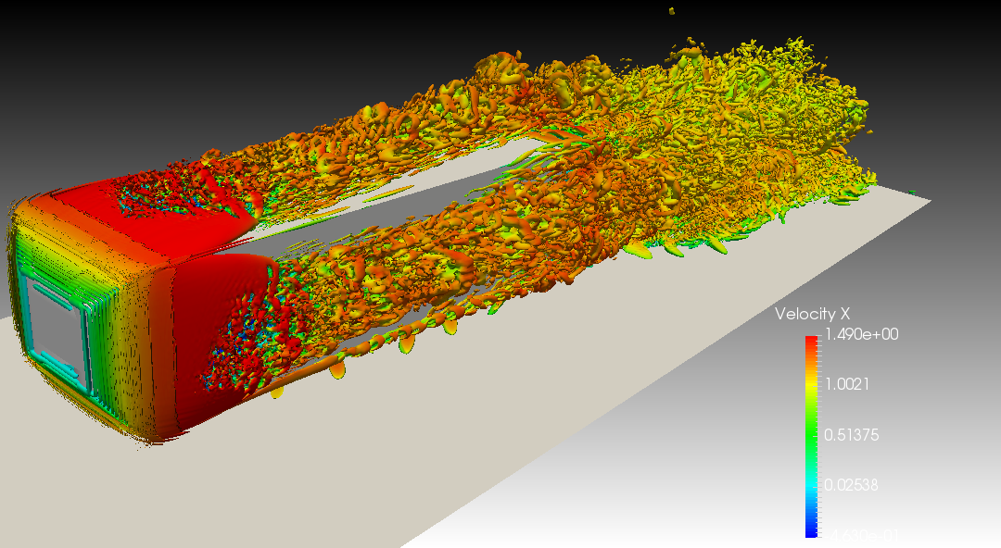
Videos are available here
Come back to first page

Simulation settings

2D Sketch
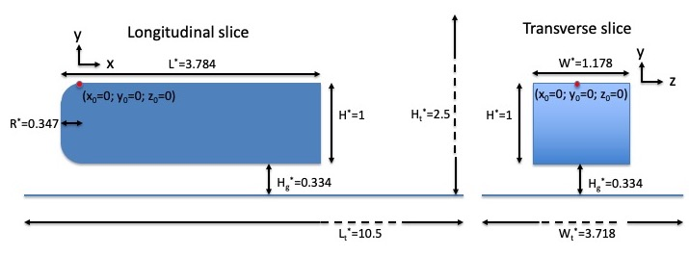

Referential : cartesian geometry
- axes :
  - x : downstream direction
  - y : normal direction
  - z : spanwise direction
- origin :
  - : upstream edge of Ahmed body top
  - : Ahmed body top
  - : mid-span of domain

Reference scales
- Density : mass density of the fluid ()
- Length : Ahmed body height ()
- Velocity : inlet bulk velocity ()
- Dynamic viscosity : dynamic viscosity of the fluid ()
- Reynolds number :

Non-dimensionalised data
- velocity :
- density :
- coordinates : , ,

Computational domain
- Domain scope
  - Downstream direction(x) :
  - Normal direction (y) :
  - Spanwise direction (z) :
  - Ahmed body size :
  - Quarter rounded edges radius around the front face of the body :
  - Ground clearance :
- Boundary conditions
  - Inlet : Uniform profile at
  - Outlet : Orlansky's type at
  - Wall conditions : Ahmed body, top and low walls of the domain
  - Symmetry : lateral ends of the domain
- Spatial resolution :
  - Grid : (33.554.432 cells)
  - About cell-size
    - (downstream direction)
    - (normal direction)
    - (spanwise direction)
Come back to first page

Data features

- Time series from probes
  - Physical quantities : velocity components along x, y and z directions (u,v,w) and pressure (p)
  - 3 probes
  - Time step= time unit
  - Time range : 71 to 303, 343 to 680, 680 to 729, 729 to 780 time units
  - Locations (In horizontal mid-plan of the body wake)
    - Xi= 4.384 , Xj=-0.5 , Xk= 0.3
    - Xi= 4.384 , Xj=-0.5 , Xk= 0.0
    - Xi= 4.384 , Xj=-0.5 , Xk=-0.3
  - File name (per physical quantity): x_ins_00000.d with x= u,v,w,p
- 3D snapshots
  - Instantaneous fields : velocity components along x,y and z directions (U,V,W) and pressure (P)
  - Recording rate : 0.5 time unit
  - Time range from from 185 to 780 time units
  - File name : res_xxxxx_yyyyyyy.d (xxxxx : MPI subdomain ID, yyyyyyy : Time ID)
    - MPI subdomain ID= 0 (No domain decomposition)
    - Time ID : 178 to 1364
- Statistics
  - fields : (i,j : indexes of direction x, y or z)
    - Mean fields of velocity components (<Ui>) and pressure (<P>)
    - Mean fields of quadratic quantities (<P2>, <UiUj>)
  - Time startup = 43 time units
  - Time range per file = 10 time units
  - Total time range from 43 to 780 time units
  - file name : rst_xxxxx_yyyyyyy.d (xxxxx : MPI subdomain ID, yyyyyyy : Time ID)
    - MPI subdomain ID= 0 (No domain decomposition)
    - Time ID : 1 to 73
Come back to first page

Database organisation

Data size : ~ 802 Gb
Main directory : /vol/DATABASE_MECA/RESTRICTED_ACCESS/DATABASE_AHMEDBODY_RE10000_DNS
For more details about files, see the wiki doc of Sunfluidh

Directories & files
/GRID : contains all files about grid setup
input data file : data_meshgen.d
report on grid features : report_meshgen.d
grid files for sunfluidh: maillx.d, mailly.d, maillz.d
check files (ASCII) : check_mesh_I.d,check_mesh_J.d,check_mesh_K.d
(3 columns : indices, cell-face coordinates, cell size)
/DATASETUP : it contains input data file for sunfluidh : input3d.dat
/TIMESERIES : contains time series recorded from probes
/TIMESERIES_T071-305 : from time= 71 to 303 time units
/TIMESERIES_T343-533 : from time=343 to 533 time units
/TIMESERIES_T533-638 : from time=533 to 638 time units
/TIMESERIES_T638-680 : from time=638 to 680 time units
/TIMESERIES_T680-729 : from time=680 to 729 time units
/TIMESERIES_T729-780 : from time=729 to 780 time units
ASCII files : x_ins_00000_full.d with x= u,v,w,p
also contains the space-averaged kinetic energy from time=326 to 561 (time step : 2.55D-02)
ASCII file : space_averaged_ke.d
/SNAPSHOTS : snapshots binary files res_xxxxx_yyyyyyy.d
/STATISTICS : statistics binary files rst_xxxxx_yyyyyyy.d
/RESTART_AR : backup/restart archives save_t361.tar, save_t561.tar, save_t638.tar, save_t729.tar, save_t780.tar
contains any file to resume the simulation at time = 361, 561, 638, 729 and 780 time units
/FROM_COMPUTATION : regroup some directories and files related to the simulation
/SLICES : slices ... not documented (old study)
Binary files : plan_id_dir_xxxxx_yyyyyyy.d
(nn : slice ID, dir : orientation, xxxxx : MPI subdomain ID, yyyyyyy : Time ID)
Come back to first page

