3D backward-facing step flow at $Re_H= 6000$
Author : Y. Fraigneau CNRS-LIMSI (yann.fraigneau@limsi.fr)
Date : August 2020
Location : DATABASE_BACKWARDFACINGSTEPFLOW_RE6000_DNS
Simulation type : DNS (Sunfluidh code)
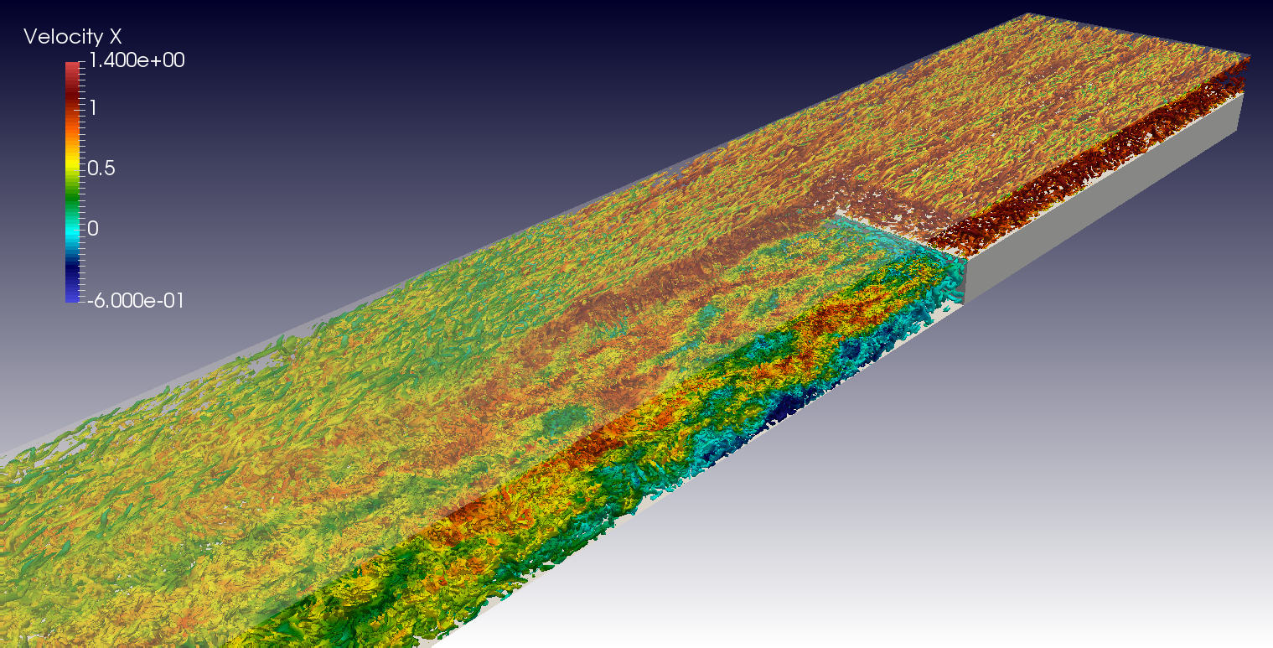
Come back to previous page

Simulation settings

Sketch
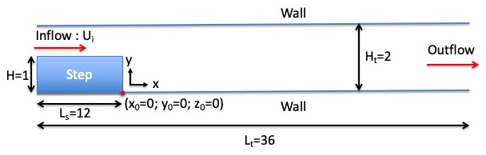

Referential : cartesian geometry
- axes :
  - x(i) : downstream direction
  - y(j) : normal direction
  - z(k) : spanwise direction
- origin :
  - : the step
  - : the bottom wall of the domain
  - : the left side of the computational domain

Reference scales
- Density : mass density of the fluid ()
- Length : step height ()
- Velocity : inlet bulk velocity ()
- Dynamic viscosity : dynamic viscosity of the fluid ()
- Reynolds number :

Non-dimensionalised data
- velocity :
- density :
- coordinates : , ,

Computational domain
- Domain scope
  - Downstream direction(x) :
  - Normal direction (y) :
  - Spanwise direction (z) :
  - Step position :
  - Step height :
- Boundary conditions
  - Inlet : Uniform profil at
  - Outlet : Orlansky's type at
  - Wall conditions : Top and low walls of the domain
  - Periodicity : lateral ends of the domain
- Domain decomposition (160 MPI subdomains)
  - Along the downstream direction :
    - 12 (between the inlet and the outlet, above the step)
    - 8 (between the step and the outlet)
  - Along the normal direction : 4
  - Along the spanwise direction : 4
  - Sketch of domain decomposition in a plan {xy} (MPI process distribution (1))
1 1 1 1 1 1 1 1 1 1 1 1
1 1 1 1 1 1 1 1 1 1 1 1
0 0 0 0 1 1 1 1 1 1 1 1
0 0 0 0 1 1 1 1 1 1 1 1
- Spatial resolution :
  - Grid : per subdomain (83.886.080 cells over the domain)
  - About cell-size
    - (downstream direction)
    - (normal direction)
    - (spanwise direction)

Data Recording : information about data types

- Time series from probes : U,V,W,P (velocity components & pressure)
  - Time step= 0.01
  - Time range : 200.0 to 513.3 time units
  - Locations (In vertical plan at )
    - Xi=-4.00 , Xj= 1.50 , Xk= 3.14 17
    - Xi=-2.00 , Xj= 1.50 , Xk= 3.14 - MPI Subdomain ID : 25
    - Xi= 0.10 , Xj= 1.00 , Xk= 3.14 - MPI Subdomain ID : 37
    - Xi= 4.00 , Xj= 1.00 , Xk= 3.14 - MPI Subdomain ID : 53
    - Xi= 4.00 , Xj= 0.01 , Xk= 3.14 - MPI Subdomain ID : 49
    - Xi= 6.00 , Xj= 1.00 , Xk= 3.14 - MPI Subdomain ID : 69
    - Xi= 6.00 , Xj= 0.01 , Xk= 3.14 - MPI Subdomain ID : 65
    - Xi= 8.00 , Xj= 1.00 , Xk= 3.14 - MPI Subdomain ID : 69
    - Xi= 8.00 , Xj= 0.01 , Xk= 3.14 - MPI Subdomain ID : 65
    - Xi=16.0 , Xj= 1.00 , Xk= 3.14 - MPI Subdomain ID : 117
    - Xi=16.0 , Xj= 0.01 , Xk= 3.14 - MPI Subdomain ID : 113
  - File name : x_ins_yyyyy.d with x= u,v,w,p and 'yyyyy' the MPI subdomain ID
- 3D snapshots (instantaneous fields : velocity components U,V,W and pressure : P)
  - Recording rate : 0.1 time units
  - Time range from from 185.3 to 513.3
  - File name : res_xxxxx_yyyyyyy.d (xxxxx : MPI subdomain ID, yyyyyyy : Time ID)
    - MPI subdomain ID: from 0 to 159
    - Time ID : from 186 to 3465
- Statistics (fields : <Ui>, <P>, <P2>, <UiUj> i,j : directions x,y,z)
  - Time and space average computation (along the spanwise direction)
  - Time startup = 180.0
  - Time range per file = 10.0
  - Total time range from 180.0 to 510.0
  - file name : rst_xxxxx_yyyyyyy.d (xxxxx : MPI subdomain ID, yyyyyyy : Time ID)
    - MPI subdomain ID : from 0 to 39 (MPI process rank where results about space average computation are stored)
    - Time ID : from 1 to 33

Database organisation

Data size : ~ 4.4 To
Main directory : /vol/DATABASE_MECA/RESTRICTED_ACCESS/DATABASE_BACKFACINGSTEPFLOW_RE6000_DNS
For more details about files, see the the wiki doc of Sunfluidh

Directories & files
/GRID : contains all ASCII files about grid setup
input data file : data_meshgen.d
report on grid features : report_meshgen.d
grid files for sunfluidh: maillx.d, mailly.d, maillz.d
check files (ASCII) : check_mesh_I.d,check_mesh_J.d,check_mesh_K.d
(3 columns : indices, cell-face coordinates, cell size)
/DATASETUP : ASCII files
input data file for sunfluidh : input3d.dat
data file for MPI subdomain distribution (MPI graphical topology): data_mpi_subdomain_layout.dat
/TIMESERIES : contains time series recorded over the time range [200,513.3]
ASCII files : x_ins_yyyyy.d with x= u,v,w,p
time series files are sliced in directories CAS-MPI160-n (n from 121 to 330)
WARNING : possible underlying of time series for these data couples :
n = (243,244):
n = (246,247):
n = (259,260):
n = (260-261):
The directory CAS-MPI160-260 contains 2 groups of
consecutive timeseries files placed in directories DIR-A and DIR-B
/SNAPSHOTS : snapshots binary files res_xxxxx_yyyyyyy.d
files stored in archive files : res_yyyyyyy.tar for each time ID
/STATISTICS : statistics binary files files rst_xxxxx_yyyyyyy.d
files stored in archive files : rst_z.tar , z is an ID number
/RESTART_AR : backup/restart archive save.tar at time 513.27
Come back to previous page

